Exams Questions

Basic 1

1. _____ is an organized sound (a)Music (b) Noise(c)Universe

2. The Tonic solfa notation has ______ major notes (a)5 (b)8 (c)6

3. Instruments placed by blowing are called ____ Instruments (a) Keyboard (b)Notation(c)Woodwinds

4. ______ is not a musical notation (a)Alphabetical notation (b)Minor notation (c)Upper notation

5. The staff have _____ lines (a) 7(b)5 (c)6

6. There are _______ types of clefs(a)4 (b) 2(c)3

7. The letter on the staff is written from the ________(a)bottom (b)top (c)middle

8. The Grand staff consists of ______ staffs (a)3 (b)2 (c)1

9. The blowing part of the recorder is called ________ (a) Mouth (b)Mouthpipe (c)Mouthpiece

10. The trumpet is played by _________ (a) Blowing(b)Beating(c) Pumping

Identify the following instruments

1.

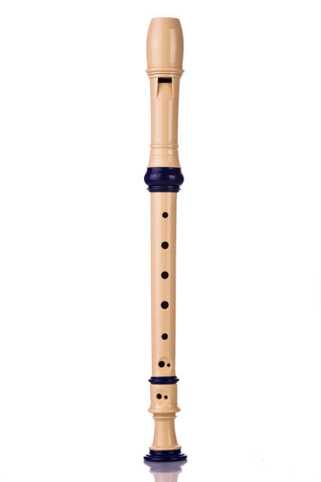

(a)Tuba (b)Recorder

2.

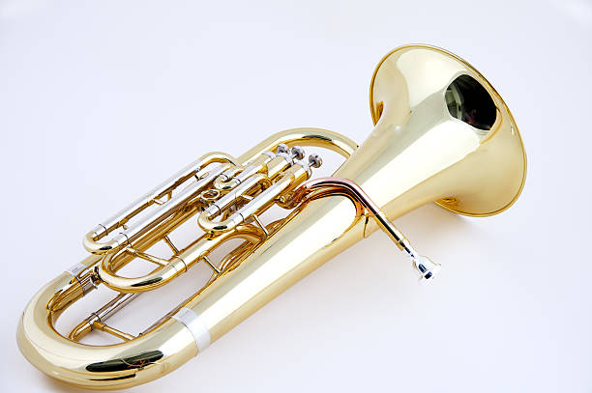

(a)Piano (b)Euphonium

3.

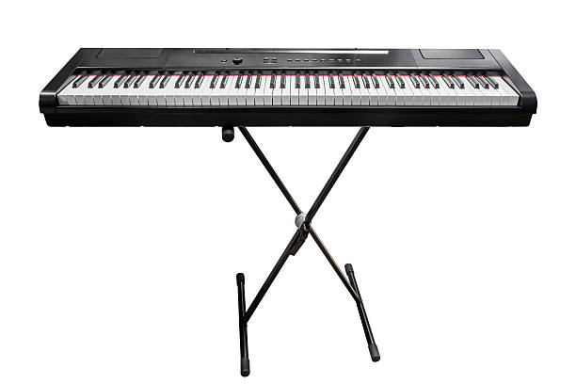

(a)Trumpet (b) Keyboard

4.

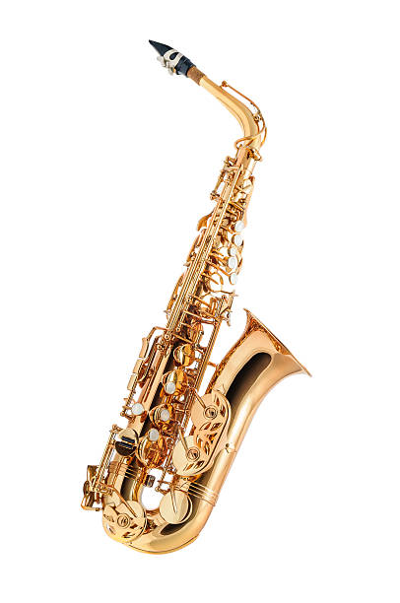

(a)Saxophone (b)Cornet

5.

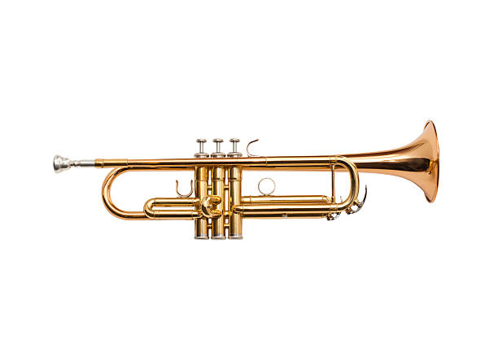

(a)Trumpet (b)Saxophone

Basic 2

1. _____ is the act of arranging sound in the manner that is pleasing to the ear (a)Music (b)Noise (c) Can

2. Music also involves singing and playing of _______ (a)Games(b)Instruments(c)Ludo

3. The trumpet is played by _________ (a)Beating(b)Pumping(c) Blowing

4. To read the staff, we start reading from the ______ (a)Top(b)Middle (c)Buttom

5. The semibreve has ______ beats(a)6 (b)4 (c)5

6. There are ____types of clefs (a) 1(b) 2(c)3

7. The ______ clef looks like a question mark (a)Bass (b)Treble (c)C

8. The following are woodwind instruments except _______ (a) Recorder(b)Guitar(c)Flute

9. The melodion is played by _______ (a)bowing (b) touching (c)blowing

10. The grand staff consists of ______ staffs(a)2 (b) 3(c)4

11. ________ is use for the sign language in music (a) leg (b) hand(c) eyes

12. The musical alphabets ranges from A to ______ (a)J (b)Z (c)G

13. The blowing part of the trumpet is called ______ (a) Mouthpiece (b)Reed (c)Mouth

14. The trumpet belongs to the ______ family (a)strings (b) brass(c)woodwind

15. _________ is a Nigerian traditional instrument (a)Piano (b) Violin(c)Gangan

Section B

Mention 5 brass instruments

1. _________________________________________________

2. _________________________________________________

3. __________________________________________________

Basic 3

1. _____ is an organized sound (a)Music (b) Noise(c)Universe

2. There are _______ types of clef (a)1(b)3(c)2

3. _________ is a Nigerian traditional instrument (a)Piano (b) Violin(c)Gangan

4. The symbol placed at the beginning of a staff is called ______ (a)clef (b) time(c)motion

5. The staff consists of ________ lines (a)3 (b) 5(c)4

6. The ________ determines the pitch on the staff (a) chord (b) mouse (c)clef

7. Kodaly notation was developed by _________ (a)Zoltan Kodaly (b)Kodaly Man (c)Sadio Mane

8. The _______ note is raised in the minor scale (a)6th(b)7th (c)2nd

9. The _______ plays the cello (a)cell man(b)celloist (c)cellist

10. Music with 2 section is called _______(a)binary(b)ternary (c)sonata

11. A musical performance that involves drama is called _______ (a)sonata(b)opera (c)oratorio

12. There are ______ musical periods (a)5(b)6 (c)7

Mention the 3 clefs

13. _________

14. ________

15. ________

Section B

Highlight 10 instrumentalist with the instrument they plays

Basic 4

1. The major scale consists of _______ notes(a)7 (b)3 (c)4

2. The minor scale consists of _______ notes(a)6 (b)7 (c)4

3. The following are types of music except ___________ (a)classical (b) highlife (c)angular

4. There are _______ types of Saxophone (a)4 (b)3(c)5

5. The alto saxophone is a __________ instrument (a)Bflat(b) Eflat (c) F

6. ___________ is the process of converting a piece of music from one system of notation to another (a)inversion (b) Conversion(c)Transcription

7. In an orchestra performance, the ________ instruments sits at the back (a)percussion (b)strings (c)woodwind

8. Sharps or flats grouped together at the beginning of a staff is called _______ (a)Note signature (b) Key signature (c) Time signature

9. The African instrument which produces sound by blowing air into its column is __________ (a)Aerophones (b) Chordophones (c)Membranophones

10. The _________ is used for playing the violin (a)boew(b)bow (c) bone

Give out 5 parts of violin

11. ___________

12. ___________

13. ___________

14. ___________

15. ___________

Section B

1. What are the various types of Saxophone

2. Explain 3 benefits of music

3. List 10 types of music

Basic 5

1. The chromatic scale movement is in _________ (a) semitone (b) tone(c) whole note

2. Kodaly notation was developed by _________ (a)Kodaly Man(b) Zoltan Kodaly (c)Sadio Mane

3. Which of the following is right (a)TTTSTT (b)TSTTSTS (c)TTSTTTS

4. The major scale consists of _______ notes(a)7 (b)3 (c)4

5. ____________ is the process of converting a piece of music from one system of notation to another (a)inversion (b) Transcription(c) Conversion

6. The trumpet belongs to the ______ family (a)strings (b)woodwind(c) brass

7. The person who leads a group of singers is called _______ (a)Music Director(b)Managing Director (c)Music Affairs

8. _________ is the act of directing a musical performance. (a)Conductors(b)Director(c)Detector

9. The symbol placed at the beginning of a staff is called ______ (a)Time Factor (b) Key Signature (c)Time notion

10. Solfa notation is invented by _________ (a)Naira Marley (b) James Brown (c)Sarah Glover

Write out 5 technical name of notes and their degrees

11. ___________

12. ___________

13. ___________

14. ___________

15. ___________

Section B

1. Mention 3 western composers

2. Highlight 3 transposing instruments

3. Construct G major scale

4. Construct D major scale

Basic 6

1. Western instruments are the instruments of the _________ (a)Europeans (b) Africans (c) Nigerians

2. A music performed for a small room is called _________ music (a) A(b)C (c)B

3. Allegro means_______ (a) piano(b) slow(c)fast

4. Adagio means ________ (a)very slow (b)grave (c)moderately

5. The mother drum is usually found in the Yoruba and _______ tradition (a)Ijaw (b)Igbo (c)Hausa

6. Piano means _________ (a)Sharp (b)loud (c) soft

7. The sign for the Flat which represents a _______ lower than the written note (a)Tone (b) Semitone(c) Double atone

8. __________ is a combination or simply arrangement of eight consecutive notes in ascending and descending order (a)Major (b)Movement(c)Scale

9. ________ are former from scales by picking any notes as the root, count a third and fifth note. (a)Triad (b)Scale (c)Movement

10. Instruments that produced a higher or lower sound that is indicated are called ___________ instruments (a)Mined (b)Transposing (c)Alternate

11. _________ instruments are instruments which notation are written at a

concert pitch (a)Non-transposing(b) Non-alternate (c) Mined

12. The only transposing instruments in the strings family is ____ (a)Cello (b)Double bass(c) Violin

13. ________ is a group of an organized musicians coming together for the purpose of choral performance (a)choral (b)song writers (c)Choir

14. The head of a choir is __________ (a) Music Director (b) Music Leader (c) Pastor

15. A composer is a person who ______

Section B

1. What is chamber music?

2. Mention 4 musical terms indicating **DYNAMICS**

3. Mention 5 musical terms indicating **TEMPO**